**• Install Power BI Desktop and share the final screenshot of the report view page which appears when power desktop starts.**

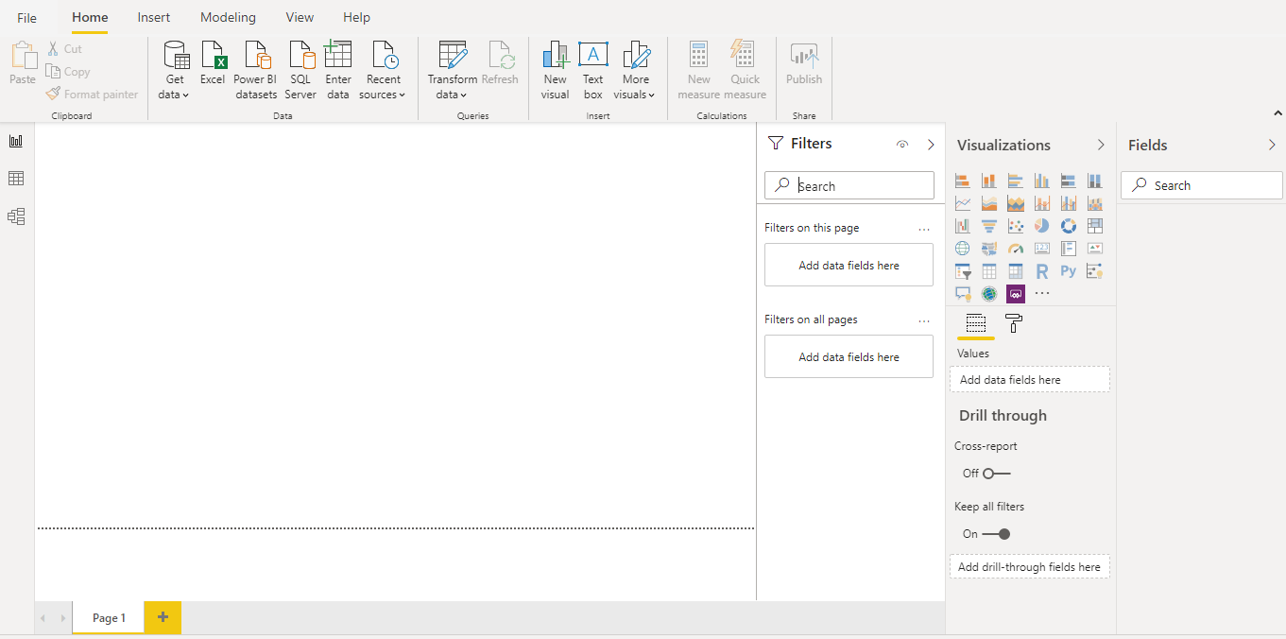

* **Prepare a document and with the following screenshot**

**− Report View**

**− Data View**

**− Model View**

**− Power Query Editor**

**− Advance Editor**

* **Report View**



**− Data View**

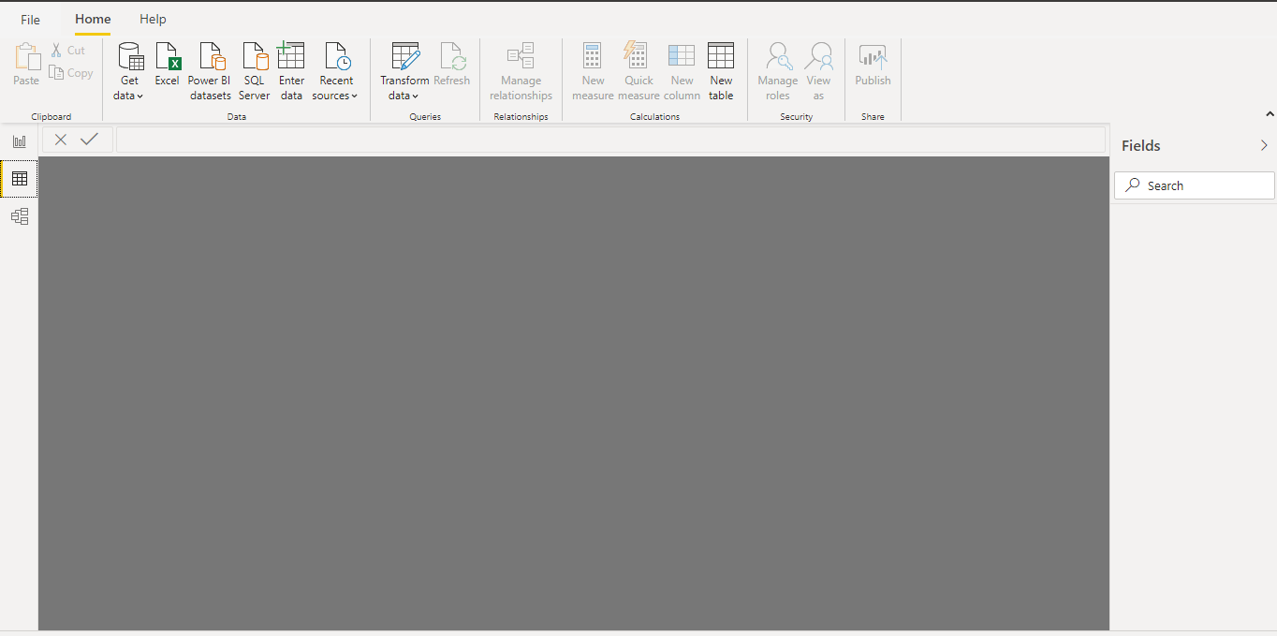

**− Model View**

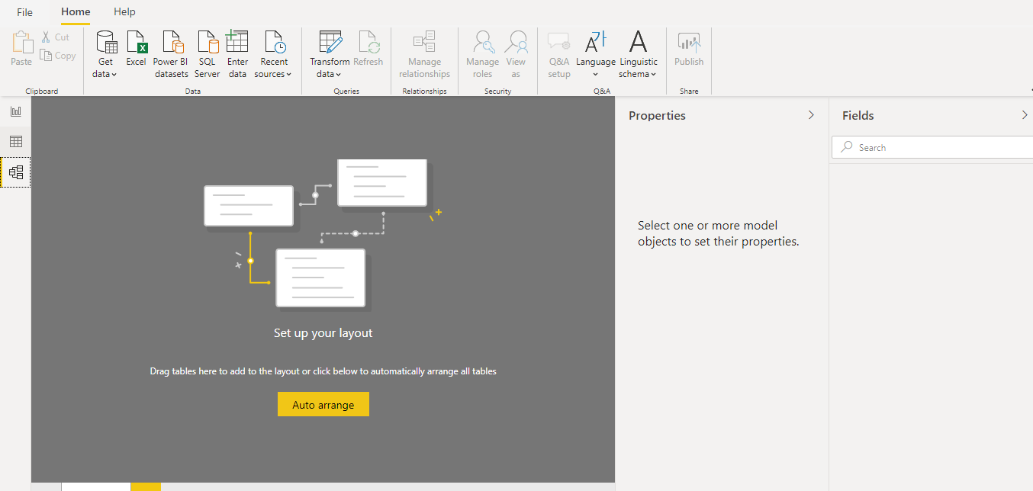

**− Power Query Editor**

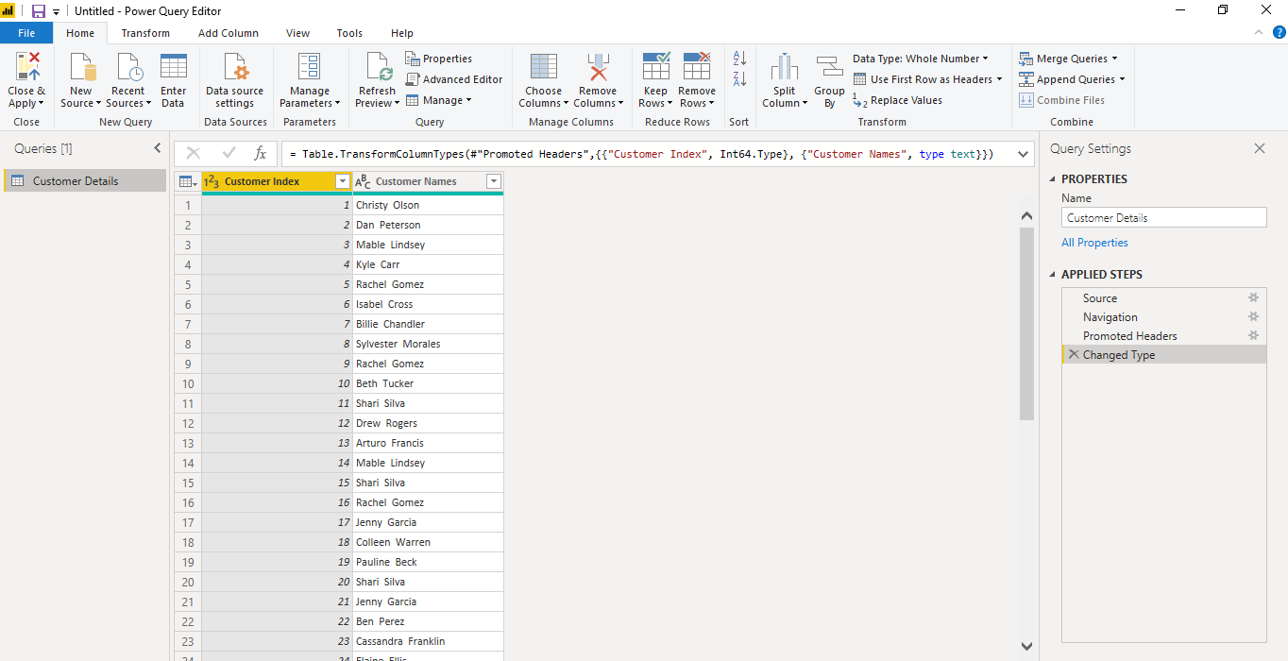

**− Advance Editor**

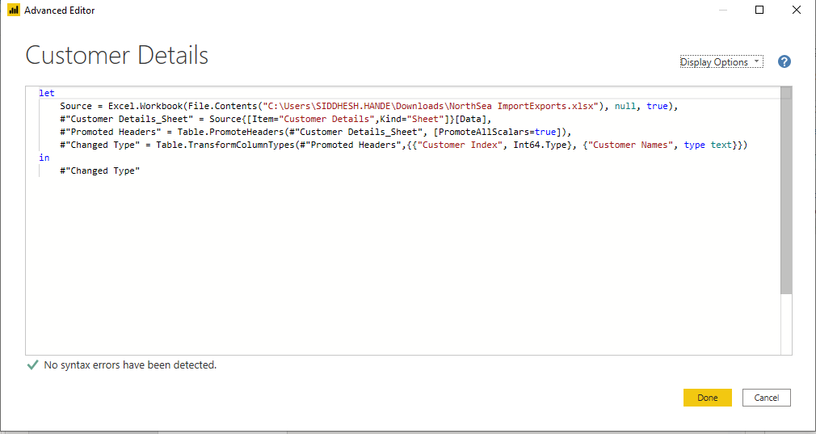

* **Prepare a document with details of the following along with their price**
* **Power BI Desktop**
* **Power BI Pro**
* **Power BI Premium**

**− Power BI Desktop**

*Power BI Desktop* is a free application which can install on local computer that connect to, transform, and visualize data. With Power BI Desktop, you can connect to multiple different sources of data, and combine them (often called *modeling*) into a data model. This data model lets you build visuals, and collections of visuals you can share as reports, with other people inside your organization. Most users who work on business intelligence projects use Power BI Desktop to create reports, and then use the *Power BI service* to share their reports with others.

**− Power BI Pro**

Power BI Pro is an individual user license that lets users read and interact with reports and dashboards that others have published to the Power BI service. Users with this license type can share content and collaborate with other Power BI Pro users. Only Power BI Pro users can publish or share content with other users or consume content that's created by others, unless a Power BI Premium capacity hosts that content. The Pro plan costs $9.99/user/month.

**− Power BI Premium**

Power BI Premium is a capacity-based offering that includes:

* Flexibility to publish reports broadly across an enterprise, without requiring recipients to be licensed individually per user.
* Greater scale and performance than shared capacity in the Power BI service.
* The ability to maintain BI assets on-premises with Power BI Report Server.
* One API surface, a consistent set of capabilities, and access to the latest features for embedded analytics

The Premium plan starts at $4,995 a month per dedicated cloud compute and storage resource. This does not include the cost of licensing for individual Pro and Free licenses required for each user in your organisation.